

Checkpoint Manual

2025

February 7-9, 2025

TABLE OF CONTENTS

GENERAL INSTRUCTIONS 3
Foreword 3
Documents 3
Checkpoint Pairings for 2023 3
Safety 3
Checkpoint Leader Duties 4
Checkpoint Volunteer Duties 6
Skier Bibs 7
Check-in and Check-out 7
Backpack Weighing 9
Food Supplies 9
Equipment 10
Communication Systems 11
Radio Operators 12
OPS 13
Safety Points 14
Road Crossings 14
Waxing Teams 15
Rental Vehicles 15
Accommodation and Meals 16
Luggage 17
SITE SPECIFIC INFORMATION 18
Gold Dorm 18
Papineauville Dorm 19
Saturday Start – Golf Heritage 21
Taunton Checkpoint 22
Esdale Checkpoint 23
Sand Pit Checkpoint 24
Sporting Clay Checkpoint 25
Montebello Finish 26
Gold Camp 27
Sunday Start - Montebello 28

OVERVIEW MAP - DRIVING DIRECTIONS 29

GENERAL INSTRUCTIONS

Foreword
This manual is intended for use by the checkpoint/task leaders of the Canadian Ski Marathon (CSM).
It is intended as a guide only. Any instructions given by the President, Event Director or Admin-2 and/or their assistant(s) override the information in this manual.

In this document, the President (Chris Teron) may be referred to as Admin-1 and the Checkpoint Coordinator (Justin Braganza) may be referred to as Admin-2.

We have tried to make the information as accurate as possible, but if you find any errors or omissions, please provide the corrections, as soon as possible, to the President (cteron@skimarathon.ca), Admin-2 (jbraganz@gmail.com) or the Event Director (bobleclair2@outlook.com).

Documents
The following documents can be found on the shared Google Drive. All CSM leaders need to check for updated and new documents right up until the date of the event. Watch carefully for the version number of the document to know if it has been revised. The information in these documents is not duplicated in this CP Manual.
- Contact information for leaders
- Overall trail map, detailed maps for each section, GPS data
- Checkpoint diagrams
- Skier and Checkpoint Times
- Road maps, driving directions and shortcuts
- Skiers Guide / Guide du Skieur
- Volunteer registration form and waiver
- Food and equipment list
- Rental vehicle lists
- Road crossing list
- Meals for volunteers
- Evaluation form

Checkpoint Pairings for 2025
Start (Golf Heritage and Montebello)
Taunton
Esdale (Saturday only)
Sand Pit
Sporting Clay (Twice on Sunday)
Finish (Montebello)

Safety
- Safety for the CSM (at the checkpoints and on the trail) is provided by a professional company of trained first responders and paramedics – Instant Santé - which specializes in safety services for large outdoor sports events. Their leader is referred to as Safety-1.
- The safety team has its own operations manual, which is separate from this one.
- They will provide safety people at the checkpoints who will monitor the health of skiers, provide assistance and first aid to skiers as required, and coordinate rescue on the trail.
- All safety vehicles have their own radios (including skidoos). Safety operates their own communication network on a different channel than Operations, but the two net control stations are co-located.
- The CSM equipment team will deliver a snowmobile to each checkpoint and the checkpoint leader will deliver the sled from Fassett in the cube van.
- The safety team will provide the snowmobile driver.
- The safety team will provide a sweep of the trail following behind the last skier on the trail in each section. Therefore, no skier will be left behind. The sweep will report its arrival at the checkpoint to the checkpoint leader, safety team and Admin-2.

Checkpoint Leader Duties
- Manage the operations of the checkpoint and its volunteers and create a positive and safe environment for all skiers.
- Attend CSM coordination meetings prior to the event along with your second-in-command and on Saturday evening of the event at 8:00pm at the Papineauville High School cafeteria.
- Prior to the event, review documents sent to you by CSM, Event Director, Admin-2 or Equipment Team leader to confirm the number of your volunteers, their accommodations, meals, rental vehicles, etc. and reply back with confirmation or changes as soon as possible.
- Review the documents on Google Drive in advance of the event so you are well prepared to lead your checkpoint and answer questions from skiers. Make sure to read the Skiers Guide, so you know the information that was given to skiers.
- Arrange that all of your volunteers sign the on-line Volunteer Registration Form and waiver or provide them with a paper copy to sign and submit to Admin-2 no later than Friday evening of the event. For volunteers under age 18, a parent or guardian must also sign the form.
- Pick up your rental vehicles on Friday, after 4:00 pm - unless an earlier time has been pre-arranged. (Additional detailed instructions below.)
- Pick up equipment and food in Fassett and Papineauville respectively on Friday evening.
- Pick up your envelope of documents from Admin-2.
- Pick up and distribute the wrist bracelets for volunteers staying in the Papineauville dorm.
- Obtain the gift and CSM badge for every volunteer from Admin-2 at the dorm on Friday evening and distribute them to the volunteers before they leave on Sunday.
- Arrive at the checkpoint on Saturday morning by the time indicated on the Skier and CP Times document and complete the set up by the time indicated.
- As soon as practical, install the radio antenna and ask the radio operator to call Net Control and announce that your team has arrived at the checkpoint.
- Co-ordinate the set-up of the checkpoint along with the other task leaders. Determine the location of the safety team, radio operator, waxing services, CP vehicles, check-in, check-out and food tables. Follow the layout on the CP Diagram but use your judgement if conditions are different than expected. (In such cases, please take into mind, skier safety, ease of access, and ease of resupply.) Coordinate the location of the check in and out with the Chip Team and their chip tracking equipment.
- Set up the new garbage bins and signage which are meant to keep the recyclable material, compost and garbage separate. Use different coloured bags in each bin.
- All volunteers at a checkpoint, including those of specific task groups, such as safety, waxing, and radio operators, report to the checkpoint leader.
- Install No Parking signs, barricades and safety cones as indicated on the CP diagram. Decide on areas for bus drop-off and pick-up and visitors' parking (where allowed).
- Confirm that the safety snowmobile, its key, sled, connecting pin and operator are at the checkpoint. Ask the operator to confirm that the snowmobile is operational.
- Verify presence and appropriate location for portable toilets on site.
- Identify a location where the skiers can leave their luggage and install the sign.
- If your checkpoint involves a road crossing, install signs on the side of the road 200 feet on either side of the trail.
- Install CSM and sponsors’ banners (where applicable).
- Set up the check-in and check-out points according to the instructions below.
- Set up the food services according to the instructions below. Assign a responsible person to manage the food, water and propane quantities.
- Call Net Control to announce when your setup is complete and ready to accept skiers.
- Coordinate all communications through radio operators.
- Be ready to receive the first incoming skier from a previous checkpoint well before their predicted arrival time in the Skier and CP Times document.
- Do not allow any skier who arrives by bus to start at your checkpoint to enter the trail before the opening time listed in the document.
- Do not allow any skier to depart from the checkpoint after the official closing time listed in the document, regardless of their category or their pleading with you. Make sure that it is clear at the check-out point that the trail is closed. Note that there is a separate and later closing time for Coureurs de Bois skiers, Half-Marathoners, and tourers who have completed the first four sections (at Sporting Clay only).
- Authorization from the President, Event Director or Admin-2 is mandatory for changing the opening or closing time of a checkpoint.
- Ensure that there is a fun atmosphere for skiers to encourage them along. If you want to create a theme for your checkpoint with special clothing or music, feel free to do so. However, this is not expected.
- Feel free to install a sign or banner promoting your group (e.g. Scouts, Guides, Viking Ski Club, etc.)
- Be familiar with the bus schedule for this year, especially if your location has additional buses taking away skiers who stop at your checkpoint. At all times, there should be a bus waiting at your checkpoint that can be used by waiting skiers to stay warm. No bus should leave, regardless of its scheduled departure time, unless its replacement has arrived. Note that the buses have their own communication system with each other and their dispatcher.
- Checkpoint leaders must inform Admin-2, as soon as possible, about icy or hazardous conditions around their CP, especially if the conditions will affect the operation of buses.
- If any food or supplies are running low, or equipment breaks that needs replacement during the same day, call OPS via radio to request re-supply. Remember that it might take a long time for OPS to arrive, so don’t leave requests to the last minute.
- If water or propane supplies are running low, call Net Control and request re-supply from the equipment team (not OPS). Don’t leave the request to the last minute as it takes time for them to respond.
- Monitor the number of skiers remaining on the trail (Net Control can provide you with the figure at any time) so that you keep enough food and warm liquids for the last skier and the sweep.
- During the course of each day, report any problems to Admin-2.
- If any skier reports problems on the trail, pass the information along to Admin-2 via radio.
- If any skier requires assistance with an injury or reports that another skier is injured, refer them to the safety team.
- Inform Net Control when the sweep leaves the checkpoint. Request authorization from Safety-1 and Admin 2 before closing the checkpoint.
- Attend the meeting of all checkpoint leaders on Saturday evening at 8:00pm in the Papineauville high school cafeteria. Bring a list of any food or equipment that are too low so you can re-supply from checkpoints that have excess or from OPS. Be prepared to give away excess food to others. Also, bring a list of issues for discussion if you think something can be done about it for Sunday. Other issues should be left for your written evaluation for next year.
- When the checkpoint closes, pick up from the radio operators their Radio Log Report, waiver forms, their statistical sheets and include them with yours.
- Request authorization from Admin-2 before leaving the checkpoint at the end of the day.
- Return all food and equipment to the CSM warehouse on Sunday.
- Return all garbage to the Papineauville High School garage and make sure to place the garbage, recyclables and compost in the appropriate containers outside the garage – green container for garbage, blue for recycling and brown for compost.
- If you happen to meet the landowner for the checkpoint, please thank them for allowing the CSM to use their property.
- Notify Admin-2 of how many people from your team will attend the volunteer banquet.
- Complete CSM paperwork and evaluate the operations of the checkpoint. Report the information to Admin-2 at the volunteer banquet.

Checkpoint Volunteer Duties
- On Friday evening, help load equipment into the cube van at the warehouse in Fassett and food at the community centre behind Papineauville High School.
- Help unload food and equipment at the checkpoint.
- Help with the setup of the equipment and signs following instructions from the checkpoint leader.
- Hook up propane burners and heat water and soup.
- Serve liquids and food to skiers.
- Loose food such as Glossettes, partial granola bars, etc., must be served in salad cups and never with your hands.
- Keep tables and surrounding areas clean at all times. Wear gloves when handling food.
- Help educate skiers to separate their garbage, recyclables and compost and put them in the correct bins.
- At closing of the CP, do a complete clean up of the site, including removal of all garbage, as well as cleaning pots and other equipment before returning them to the warehouse. There is no water available at the CSM warehouse

Skier Bibs
- The category of skier may be recognized by their bib numbers:
Gold Coureurs de Bois 1 to 999
Silver Coureurs de Bois 1000 to 1499
Bronze Coureurs de Bois 1500 to 1999
Tourers (individual skiers) 2000 to 2999
Tourers (teams) 3000 to 4999
CSM Taster 5000 to 5999 (The last section each day)
Half Marathon 6000 to 6999 (The last three sections each day)
Special 8000+
Last minute skiers 9000+
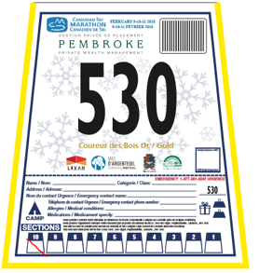
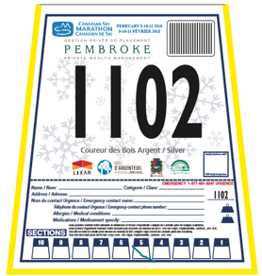
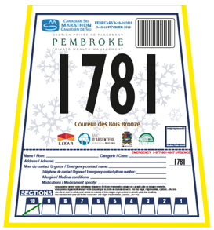
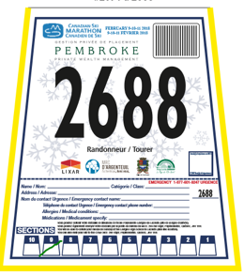
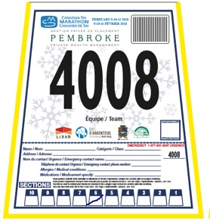
Gold Silver Bronze Tourer Team
- Skiers who have registered for many years can receive permanent bib numbers and special bibs:
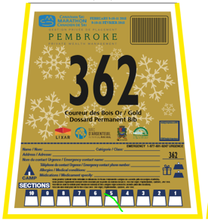
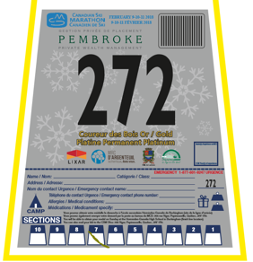
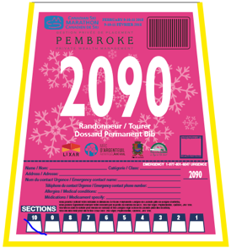
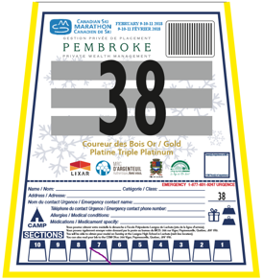

Permanent Gold Permanent Platinum Triple Platinum Quad Platinum Permanent Tourer

- Skiers who have achieved gold five times are given a permanent bib number (Currently bib 1 to 463). Skiers with 10 golds receive a platinum award. 20 golds is double platinum, 30 golds is triple platinum and 40 is quadruple platinum. A gold skier with a permanent number can register in future years for any category, not just Coureurs de Bois. Tourers who have skied over 60 sections over the years receive a permanent bib number and a pink bib (currently numbers 2000 to 2152). Nine skiers have Double Pink, having skied over 100 sections.

Check-in and Check-out
- Install flagging, signage and cones to properly indicate the trail in and out of the checkpoint.
- At check-in, 50 metres before the arrival, place on the trail the sign indicating separate lines for Coureurs de Bois and Tourers. Give precedence to Coureurs de Bois.
- If there are safety vests available, the check-in / check-out volunteers should use them to identify themselves.
- All skiers will wear an electronic chip that automatically records the time and location at each check in and out. Two chip teams will be responsible to set up the hardware at each check in and out. It will consist of a wire loop under the snow connected to a black box sitting on the snow beside the trail. Nearby will be a cell phone that receives the data from the skier’s chip and transmits it to the internet. The wire loop might be installed at the normal check in and out location but might be installed further away where there is less chance of a skier not crossing over the wire. There might be wood stakes and caution tape installed by the team to create a funnel and ensure that skiers cross over the wire. By using this technology, event organizers will know at all times how many skiers are in each section. Checkpoint leaders will no longer have to submit hourly numbers to net control. At any time, a checkpoint leader can use the radio to ask net control how many skiers are in their section or may be able to obtain this data on-line. During the event, skiers or their friends will be able to go on-line and find out where the skier was last recorded. The system does not know where a skier is located, just the time of day at each check in and out. Skiers can choose one of four locations to pick up their chip - on Friday night or Saturday/Sunday morning (Gold dorm, Papineauville dorm, Chateau Montebello) or at the start (CP1 on Saturday). Skiers cannot pick up chips at any other checkpoints. The chips are not disposable and must be returned by the skier at their last checkpoint, or the skier will be charged $75.00 (see more details below). On both days, soon after the checkpoint closes, the chip team will return to remove the equipment.
- Assign a volunteer to mark the box on each skier’s bib using a coloured Sharpie. Skiers' bibs are marked at check-out and check-in. At the check-out, mark the section being started with one diagonal line through the box. At the check-in, mark the number corresponding to the section just completed using the opposite diagonal line so that the box now has an X through it. The markings on the CSM bibs are used for backup to the chip data and for determining the awards at the end of the event. See a full description of the bib marking in a separate document on the Google Drive.

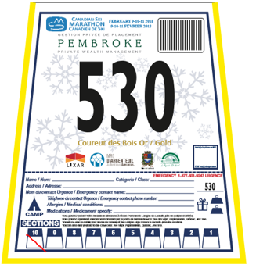
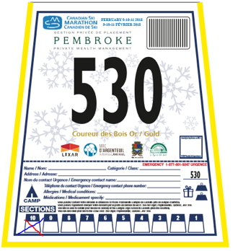

- A specific colored marker is assigned for each checkpoint:
Start = Orange Taunton = Green Esdale = Red
Sand Pit = Purple Shooting Clay = Black Finish = Blue
Camps (CdB Gold only) = Black
- Assign another volunteer to remind every skier at check-in that they must return their chip if they are not continuing further. Skiers who ski on Saturday and plan to continue on Sunday will keep their chip overnight. Skiers who are finishing are tired. Offer to take their chip. Orange buckets will be provided at the check in to collect chips.
- Assign another volunteer to check every bus just before it leaves the CP taking skiers back to town. Ask the same questions about returning the chips. On Sunday, no skier getting on a bus should still have a chip.
- Ensure that there are several people marking bibs and checking-in skiers (especially at rush times). Check-in must be rapid to avoid keeping skiers waiting. The wait should be no more than 2 or 3 minutes at the check-in and check-out.
- Assign another volunteer to stop every bus just before it leaves the checkpoint and ask all skiers on the bus if they have returned their chip. Except for skiers leaving on Saturday who expect to continue on Sunday. No skier leaving by bus on Sunday should still have a chip.
- If a skier mentions that he or she helped another skier who was injured and that he or she was delayed for that reason, a report must be submitted including the following information: name and bib number of the delayed skier, name and bib number of the injured skier, amount of time by which the skier was delayed, section number in which the incident occurred, name of volunteer who received the information. This report must be given to Admin-2 the same day.

Backpack Weighing
- The silver level of the Coureurs de Bois can only be attempted after completing the Bronze CdB. A CdB Silver level is obtained by successfully completing the 10 sections of the trail while carrying a backpack weighing no less than 5 kilograms.
- Backpacks will be weighed at Sand Pit Checkpoint on both Saturday and Sunday.
- Using the scale provided, please weigh the backpacks of the CdB Silver/Argent skiers. They can be identified with bib numbers 500-999.



Food Supplies
- Plan for 60% of your food supplies to be used on Saturday and 40% on Sunday.
- Food and beverages, including hot food and beverages, must be ready when the first skiers arrive at the checkpoint. You should plan accordingly.
- Fruit and bagels should be stored in a warm place during transportation and storage to prevent freezing. For example, leave them in your room at the high school at night. Store them in the front of the cube van during the day and keep them at a temperature above the freezing point. Only put out a small quantity of bananas at a time on the food tables for skiers.
- When the team arrives at the checkpoint, one of the first tasks is to start heating water since it takes a long time. Start by finding an open and level location to place your burners. Dig out snow if required. Place burner guards (plywood sheets with metal tops) on top of concrete blocks when the surface is level. The burners can then be placed on top of the burner guards. Attach the burners to the tanks, and ensure that the tanks are not too close to the active burners. The burners have adjustable sleeves that can regulate the amount of air feeding the flames; these have already been pre-set, so don’t adjust them unless necessary. When filling water, fill pots only half way so the water heats up more quickly. Wipe liquid soap under the pots and 2/3 up the side before placing them on the burners, to facilitate the cleaning at the end.
- Use burners and pots to heat water only, not energy drink or honey water. Hot water is then transferred into clean barrels and then the energy drink powder and honey are added.
- A typical checkpoint has three burners and pots. Use two for water and one for soup.
- When making soup, add one can of water for every can of soup.
- When mixing Gatorade energy drink, add powder to suit taste.
- The yogurt, hot dogs and cakes are for volunteers, not skiers. Volunteers include the checkpoint team, safety, waxing, radio and any visiting volunteer teams.
- The checkpoint located after the second section of each day (Esdale-Saturday and Sand Pit-Sunday) also serves warm chili to skiers.
- The checkpoint located after the fourth section of each day (Shooting Clay) also serves hot dog wieners (no buns) to skiers.
- At the end of the first day (Saturday), the checkpoint leader must prepare a written inventory of food and supplies and bring it to the Saturday night Operations meeting. During the meeting, be ready to report shortages and excess quantities. Checkpoint leaders will do any necessary exchanges of food after the meeting to ensure appropriate starting supplies on Sunday morning.
- Just before the checkpoint closes on Sunday, OPS will pick up all excess food so that it can be used at later checkpoints along the trail. Retain enough food and warm liquids to serve the skiers who haven’t arrived yet at the checkpoint.

Equipment
- The equipment and supplies must be picked up at the CSM warehouse in Fassett on Friday before 20:00. The equipment will be loaded by the Equipment Team so only the cube van should go to the warehouse, not the entire team of volunteers. The checkpoint leader must verify his/her equipment before loading the truck and, to the extent possible, ensure that it is in good working order (note that you will not be able to test burners and some other equipment at that time).
- The food supplies must be picked up from the community centre behind Papineauville High School, after picking up the equipment, and before 20:00. Food quantities must be reviewed against the inventory list. Checkpoint leaders must have sufficient volunteers to pick up the food and load the truck.
- At the same time, pick up propane tanks and fill water containers. The water barrels and jerry cans that are transported to the checkpoint by the cube van must be filled at the Papineauville garage on Friday evening. However, since the trucks are not left inside for the night, leave the containers in your truck during the night and only fill them in the morning before departure to prevent them from freezing.
- At all times at the Papineauville High School, the keys must be left in the cube van and the name of the team must be visible on the vehicle dashboard so that the Equipment Team can move cube vans if required.
- Toilets should be kept clean at all times and supplied with sufficient toilet paper. Cleaning can be done by splashing the interior of the toilet with a pot of warm water. Toilet paper should be placed on the toilet paper holder and not left in the seating area. A volunteer should be assigned to clean the toilets once every half hour.
- Burners are to be placed on the plywood platform with steel top plate, which in turn is placed on concrete blocks.
- Burners should be monitored at all times. Ensure that there is a clear area around the burners, and that propane tanks and their connecting tubes are not too close to any open flame.
- Directional signs on roads for visitors and buses will be installed by the equipment team and are not the responsibility of the checkpoint leader.
- During the CSM, any equipment that is extra, missing, malfunctioning or damaged must be recorded and reported to Admin-2 at the end of the event. However, if additional or replacement equipment is needed during the day, ask OPS via radio.
- CP/Task Leaders are responsible for the equipment while it is in his/her possession. Any breakage or loss should be reported to the supervisor at the storage garage or Admin-2 as soon as possible.
- The equipment must be clean when it is returned; if not, it is the responsibility of the checkpoint leader (and volunteers) to wash it before going home. The responsibility for returning clean equipment is that of the checkpoint leader, not the truck driver. Since there is no water available at the CSM warehouse, everything must be cleaned at the checkpoint.
- Two old tables should be made available to the Waxing Team at each checkpoint (if available).
- If possible, try to make arrangements with the property owner so that the Waxing Team can have free access to electricity, if needed.
- All Saturday and Sunday garbage must be left in the garbage bin at the Papineauville school on both days. Take care to place garbage, recyclables and compost in the appropriate locations.

Communication Systems
- There will be two separate communications systems. One is exclusively for Safety and will be operated by the safety personnel at every checkpoint. The other is for Operations and follows the same procedures as in past years.
- Communications use commercial radios rather than amateur Ham radios. Each checkpoint and mobile team will have a commercial radio. The equipment is provided to CSM through a new supplier, Exelradio, in Gatineau.
- Radios at checkpoints may have a small antenna mounted on the vehicle roof or have a very tall antenna mounted vertically on a pole and securely to the rear corner of the cube van using cable ties. There will be a long antenna wire leading to the radio. The radio can be located in the front seat of the cub van or in the car of the radio operator, if located right beside the cube van.
- All antennas are omni-directional and do not have to be oriented. However, the higher the antenna, the better. The short magnetic-based antennas must be put on a metal (steel) surface, such as the cube van roof. DO NOT put it on top of the cube van box – most are non-metallic.
- The radios use 12v power from your vehicle’s cigarette lighter adapter.
- The radios at checkpoints will be operated by a radio operator. Give your message to them to transmit for you. In return, if they receive a message for you, they will leave their vehicle to find you and give it to you.
- All communications are controlled by the radio operator at Net Control. Never transmit a message to anyone without first talking to Net Control and seeking their permission to call another station.
- Keep messages simple, brief and clear. Other stations are often waiting their turn to talk.
- Never refer to a CSM official or CP/task leader by name on the radio. Always use their tactical call sign:
Role | Person | Call sign
CSM President | Chris Teron | Admin-1
Event Director | Bob Leclair | Event-1
Safety Director | TBA | Safety-1
Checkpoint Coordinator | Justin Braganza | Admin-2
Checkpoint leaders | Various | Checkpoint 1, 2, etc.
Safety point leaders | Various | Safety point 1, 2, etc.
Equipment/logistics leader | Jean-François Picard | Logistic-1
Equipment vehicles | Various | Equipment 1, 2, 3
Water and propane | Various | Propane 1, 2
Skidoo delivery | Various | Transport 1, 2
OPS | Chris Bolestridge | OPS
Chip leader | Roger Egan | Chip leader
Chip team 2 | Harrie Jones | Chip 2
Ski Doo operators | Various | Skidoo A, B, C, etc.

- If an emergency or safety situation develops, Net Control may instruct all radio traffic to hold until the priority communications are complete.
- In the event that the commercial radio does not work, or if you wish to communicate privately with another station, the radio operators should have backup HAM radios. Failing that, you may try using cell phones by voice or text messaging. Refer to the list of all contact numbers included in your envelope of documents received from Admin-2.
- Some checkpoints will be provided with cell phone boosters. Boosters have a magnetic roof-top antenna and also use 12v from your vehicle’s cigarette lighter adapter. Most boosters act as a cradle for your phone. Your cell phone must be sitting in the cradle without any protective case.
- Some checkpoints have strong cell coverage using both Rogers (and Fido) and Bell (and Telus, Koodo and Virgin) towers. Others only have coverage from one of the two towers. Some have no coverage, even with a booster. Check the details in the checkpoint-specific instructions at the end of this document.
- The GME safety team may also carry satellite phones, if there is an absolute CP emergency and no other means of communication are available, you may request the safety team to use their satellite phone, if available, to contact the CSM emergency number at 1-877-495-2176.

Radio Operators
- The radio personnel are present to facilitate all communications for the CSM. They are in continuous contact with the checkpoints, the Event Director, Admin-2, and other operations vehicles. Radio operators are situated at every checkpoint and handle the radio communications for the checkpoint leader.
- Radio operations are managed by a Net Control, which is situated in the town hall of Notre-Dame de Bonsecour, near Montebello.
- All radio communications go through Net Control during the CSM. No radio operator is to call another radio operator directly without asking permission of Net Control.
- Messages regarding safety should be communicated by safety personnel over their own network who will deliver them to Safety-1.
- Radio operators at checkpoints and Net Control personnel should keep a log of their communications and of checkpoint statistics. These documents should be given to Admin-2 at the skiers’ banquet on Sunday night.
- Radio personnel for a given checkpoint are to arrive on site at the same time as the checkpoint leader, and they must stay until they have clearance to leave from Admin-2. They must confirm, by reporting through Net Control, the following activities: (1) their arrival at the checkpoint with the checkpoint leader, and (2) when the checkpoint is operational (check with checkpoint leader), and (3) at 15 minutes after every hour, the cumulative number of skiers.
- They should also complete the statistical forms during the day and return them to the checkpoint leader when the checkpoint closes.
- Net Control must record all information provided by checkpoint radio operators and be ready to relay it to Admin-2 on request. Radio personnel, including Net Control, must be diligent in recording required information as requested by Admin-2. Please note that because Net Control is logging the details of all communications, DO NOT talk too quickly. Allow time for them to properly record your information.
- Radio operators will be provided meals and accommodation in the same manner as other volunteers.
- The checkpoint leader will ask radio operators to complete volunteer registration and waiver forms.
- The checkpoint leader will take care of distributing any CSM souvenirs to the radio operators.

OPS
- Be at the equipment warehouse at 15:00 on Friday afternoon to pick up equipment according to the distribution list.
- Then go to the Papineauville High School garage to help Admin-2 unload, sort and distribute food for each checkpoint. Assist checkpoint teams when they are loading their cube vans with food. Load your vehicle with an inventory of extra food and equipment according to the distribution list.
- All weekend, listen closely to your radio and cell phone for requests from Net Control, the Event Director and Admin-2. If you are out of range while driving between checkpoints, check with the radio operator at the next checkpoint if you missed any messages.
- When you arrive at each checkpoint and when you leave a checkpoint convey your location and destination to Admin-2 via net control.
- During the weekend, respond to requests from checkpoints by delivering missing equipment, supplies and food. Water and propane are re-supplied to each checkpoint by a separate team.
- Respond to the operational needs and questions of the checkpoints.
- Respond to requests from the Event Director and Admin-2.
- Over the weekend, develop a working knowledge of the location of road crossings. As you are driving between checkpoints, try to pass by these locations. Many road crossings with low volumes of vehicles do not have volunteers at them. Be prepared to stop at them and fix the snow with a shovel.
- On Saturday and Sunday morning, it is not essential that you be at the start at 5:40am. Have your phone turned on in case you are needed then. Be in the area of the second checkpoint as they are finishing their setup to be ready for the first skiers. If a checkpoint has forgotten something important, they will tend to realize it and call you as they are setting up.
- All weekend, maintain a written inventory of your food supplies, recording what food was given or taken from each checkpoint, using the designated form.
- On Saturday evening, attend the meeting of all checkpoint leaders at the Papineauville High School cafeteria at 20:00. Bring your food inventory. Be ready to trade food between checkpoint leaders based on who is low and who has excess.
- At the very beginning of each day, when leaving Montebello, drop in to the Papineauville High School and pick up box lunches for yourself, the Admin-2 team, and any others requested for you to deliver during the day. When you first see Admin-2, give them their lunches.
- During the day, pick up skiers’ luggage at checkpoints (but not at the start on either day, which is handled by the equipment team) and deliver them on Saturday to Papineauville School or to the Château Montebello as specified on the baggage tag (if no specification, take luggage to Papineauville). On Sunday, deliver all luggage to the banquet site (not the finish or Chateau Montebello). Each checkpoint should have a sign indicating where skiers may leave baggage. Check with the checkpoint leader if they are aware of any baggage or lost and found items. Try not to keep luggage from early checkpoints in your vehicle all day or skiers may be waiting a long time to retrieve their luggage at the end. This may require one or two special trips during the day to deliver it.
- On Sunday, near the closing time of checkpoints, pick up any food that is left over and any equipment that might be useful later on in the day at another location, and distribute these items to a checkpoint closer to the finish as needed or as specified by Admin-2.
- Priority of tasks: food, equipment, and baggage.
- Do not leave your last CSM location on Sunday evening until you have received the OK from Admin-2, in case your assistance is needed elsewhere.
- At the end of Sunday, return to the warehouse to unload all food and equipment. Give them your food inventory, or send it to the equipment leader within a few days.
- Complete an evaluation form after the event including suggestions for changes and improvements, and submit to Admin-2.

Safety Points
- Near the midpoint of most sections, a team will provide water to skiers and limited safety services.
- Some teams bring their own small burners to warm the water.
- Each safety point team will have a commercial radio to call Safety-1 for assistance when needed but will not otherwise be monitoring the radio to hear calls. See the section in this manual describing the communications systems.
- If a skier needs assistance such as first aid or evacuation from the trail, use the radio to call Safety-1 and indicate what assistance is required.
- If the safety point is situated at a road crossing, place snow on the road to allow skiers to cross without removing their skis.
- Safety teams are not permitted to stop traffic for skiers. They stop skiers and advise them when it is safe to cross the road. Only first responders can stop vehicles.
- Safety teams report to Safety-1.

Road Crossings
- Where the ski trail crosses a road with sufficient traffic, teams are assigned to assist skiers. Many road crossings have so little traffic that no assistance is required or provided.
- Where the trail crosses a busy highway, the team may include first responders such as the local fire department.
- Crossroad signs should be placed on both sides of the road, 150 feet before the road crossing in each direction.
- Volunteers are not permitted to stop traffic for skiers. They stop skiers and advise them when it is safe to cross the road.
- First responders are permitted to stop traffic.
- If a road crossing team requires assistance, they can use their cell phone to call Safety-1.

Waxing Teams
- The waxing team at each checkpoint/accommodation site is there to offer a free service to skiers.
- One waxing team is assigned to each checkpoint/accommodation site.
- The waxing team for each checkpoint should be ready to provide services as soon as the checkpoint is operational. They should stay at the site until the check-out closes and they receive clearance to leave from the checkpoint leader.
- The checkpoint leader is responsible for giving the waxing team a location at the checkpoint so that they are not in the way but are still able to help the skiers and are clearly visible.
- The equipment for each checkpoint and accommodation site includes two tables for use by the waxing team. Checkpoint volunteers should take these tables to the waxing team.
- The waxing team might ask to have access to electricity. It is the responsibility of the checkpoint leader to make arrangements with the landowner for such access, but only if this is possible at no cost to the CSM. It is the responsibility of the waxing team to provide their own electrical equipment and extension cords.
- The waxing team leader reports to the checkpoint leader.
- The checkpoint leader should place the temperature sign close to the waxing station; make sure to pick it up at the end of the day.
- The equipment for each checkpoint should include an air thermometer and a snow thermometer. These items should be made available for use by the waxing team, if needed. Be sure to pick up the thermometers from the waxing team at the end of the day.
- The Waxing Coordinator will take care of the required paperwork for the Waxing Team (vehicle permits, volunteer waiver forms) as well as distribution of any CSM identification and souvenirs.
- Weather reports and forecasts are available by radio (104.9 FM Lachute - 450-562-8862 or 102.1 FM Hawkesbury) or from Environment Canada – Mirabel Office 450-476-3029.

Rental Vehicles
- The number of rental vehicles required and the pick-up location and time, as requested by the CP/Task Leaders, is indicated in a separate document on Google Drive.
- The drivers of rented vehicles must be at least 21 years old (except the 15-passenger van, for which the age requirement is 25 years old).
- The contract for each vehicle should include the following statement: "That any driver authorized by the CSM may drive the vehicle". The CP / Task Leader is responsible for all of his/her drivers and vehicles and must be informed about and must authorize any switch of drivers.
- A copy of each person’s driver’s license must be scanned and emailed to the CSM office in advance of the event for them to be covered by insurance.
- Whenever possible during the weekend, gas should be obtained from the Harnois gas station in Papineauville with which the CSM has made prior arrangements. The driver must present a CSM gas coupon, sign the CSM report sheet at the gas station and fill in all of the necessary information. The driver must then complete the driver’s gas fill-up form (in addition to the form at the gas station) and give that form to his/her checkpoint leader who must return it with his/her documents to Admin-2.
- Before returning the vehicle at the end of the weekend, please fill it at the Shell station at 1050 Boulevard Saint-Joseph, Gatineau (Hull sector), unless this is too far out of your way. In that case, fill it yourself and submit receipts for reimbursement.
- The relevant Checkpoint or Task Leader must approve all expenses incurred by drivers or other volunteers before they can be submitted to the CSM office for reimbursement. All expenses must be supported by receipts. Once approval has been obtained, volunteers should forward their receipts for gas obtained at other than the designated gas station and receipts for any other expenses to the CSM Office within 3 days after the CSM. It may take up to 3 weeks for reimbursements to be issued.
- No smoking is permitted in the rented vehicles.
- All diesel vehicles should be plugged in when not in use. It is the responsibility of the checkpoint leader to obtain a long electric extension cord from the equipment team for this purpose. (Do we actually rent any diesel vehicles?)
- In case of emergency or any problems with any rental vehicles, the driver should contact Admin-2, through a radio operator, before contacting the rental company. If Admin-2 cannot be reached, the emergency roadside assistance numbers for Budget vehicles are as follows: Ford vehicle 1-800-665-2006, GM vehicle 1-800-268-6800 or Budget Ottawa Office 613-729-6666 (if a replacement vehicle is needed).

Accommodation and Meals
- Every checkpoint and task team has accommodation on Friday and Saturday night at the Papineauville High School (except for the team managing the Gold dorm). Teams preferring accommodations at Gold Dorm on Friday night should contact the Event Director ahead of the marathon.
- Checkpoint and team leaders must review the document on Google Drive indicating how many people will be staying at the dorm.
- Everyone staying in the dorms must wear a colour-coded bracelet indicating that they are authorized to be there. Bracelets are supplied in the envelope of documents provided to leaders in the garage.
The colours are:
Volunteers: Orange Skiers (Friday and Saturday): Blue
Skiers and volunteers (Gold dorm): Mauve Skiers (Saturday only) Yellow
- The parking lot at the rear of the Papineauville school is reserved for CP vehicles only; personal and skiers’ cars should be parked in the left-side parking lots. Army vehicles should be parked in the right (east) side parking lots, at the end of the garage (student parking). No personal or skiers’ vehicles should be parked in front of or beside the garage. These two locations should be monitored by two school volunteers at all times.
- The swimming pool in the Papineauville school is available for use on Friday and Saturday evenings from 7:00pm to 9:00pm.
- Meals for volunteers will be available at local restaurants at specified periods. Refer to the document on Google Drive to see when and where your team takes its meals. Meal coupons are distributed to each volunteer by their leader and then given to the restaurant in exchange for a meal. Please respect the times!
- Lunch is prepared at checkpoints for all checkpoint volunteers. The checkpoint leader must invite all checkpoint personnel (radio, safety, waxing, any others) when lunch is ready to be served. Lunch should be available between 11:30 and 1:00 pm. Make sure that all volunteers working at your checkpoint know when lunch is served and that they receive hot dogs, cake, etc. This includes anyone who is temporarily at your checkpoint.
- Box lunches will only be provided to those volunteers who cannot be at checkpoints to eat. The box lunches can be picked up at the Papineauville dorm early on Saturday and Sunday morning.
- No meals will be reimbursed without pre-authorization from Admin-2. Checkpoint leaders must convey this restriction to their volunteers.
- CSM will have articles for sale at the Papineauville and Gold dorms and at the Chateau Montebello.

Luggage
- Skiers may leave their luggage at any checkpoint or accommodation site for transport to accommodation locations, depending on the day. The Equipment team and OPS will ensure that all such luggage is taken to the proper place. On Saturday, luggage with no tag will be taken to the Papineauville dormitory. On Sunday, luggage with no tags will be taken to the banquet site. On Saturday only, luggage with yellow tags will be taken to the Château Montebello.

Bib and Chip Distribution
- All skiers will wear an electronic chip that automatically records the time and location at each check in and out. During registration, skiers had to choose one of these five locations and times to pick up their package (which includes their bib, chip, crest and souvenir). They may not change their pickup location or pick them up anywhere else.
- Papineauville High School (Friday 5:00 pm to Sunday 8:00 am)
- Château Montebello (Friday 5:00 pm to Sunday 8:00 am)
- Gold dorm (Friday evening only 5:00 pm to midnight)
- Golf Heritage Start (Saturday morning only 5:00am to 8:30 am)
- The bibs and chips will be inserted into the skier envelopes at the office in advance of the weekend. Each envelope will have a label with the skier’s name and they will be sorted in alphabetical order.
- Skiers picking up their package at the first three locations may not necessarily be staying there.
- Chips are individually assigned to each skier and skiers may not trade them with any other skier.
- Chips can be worn anywhere on their body. They can be put under clothing or on a backpack.
- If the skier’s envelope cannot be found, it is likely they have come to a different pickup location than the one they chose when they registered.

Missing Chips and Bibs
- If a skier arrives at any checkpoint and has lost or forgotten his/her chip and/or bib, the checkpoint leader will have a few spares. The leader must inform the Event Director of the name of the skier, new bib number and/or new chip number as soon as possible, though the skier may start skiing with the new chip before the Event Director has been informed.

SITE SPECIFIC INFORMATION

Gold Dorm

Location:
- Auberge Golf Heritage, 70 Rte 323, Notre-Dame-de-la-Paix, Québec J0V 1P0
- 45.76746252646567, -74.98152741526494

Communications:
- No radio required
- Cell phone coverage is weak

Specific Tasks for the Leader
- Être prêt à recevoir les skieurs à partir de 17 h vendredi soir. Le sous-sol sera accessible à partir de 16 h pour l'installation.
- Enregistrer les skieurs de dernière minute.
- Most skiers staying at the Gold dorm will be picking up their envelope with bib, chip and souvenir at the dorm. There will also be other skiers arriving to pick up this material but not staying at the dorm. See instructions elsewhere in this document.
- Lors de l'inscription des skieurs, le nom du skieur doit être surligné sur une des feuilles « Alpha GOLD ». Leur remettre leur bracelet de couleur Mauve. Tous doivent le porter, incluant les bénévoles. Vérifier les bracelets le matin au déjeuner.
- Regrouper les gens par catégorie dans les locaux: skieurs et bénévoles.
- Identifier sur la porte de chaque local avec une pancarte / feuille qui se couche dans ce local. Indiquer aux skieurs et aux bénévoles qu’ils ne peuvent changer de local sans l’autorisation des responsables.
- CSM staff may be at the school to sell souvenirs.
- Le déjeuner doit être servi à 3 h 45 pour les bénévoles seulement, et de 4 h 15 à 5 h pour les skieurs. Informer le personnel que le déjeuner chaud doit aussi être prêt pour 3 h 45 pour les bénévoles.
- S’assurer que le pourvoyeur ait de la nourriture chaude et complète, selon le menu, jusqu’à la dernière personne à être servie, selon l’heure spécifiée.
- Avoir un endroit précis près de la porte d'entrée pour le dépôt des bagages. Personnel vont les ramasser à 5 h 15. Il est peut-être possible de stationner le camion près de l'école et inviter les skieurs à déposer leurs bagages directement dans la boîte du camion. Faire les arrangements avec le chauffeur qui couchera à l'école.

Specific Tasks for Volunteers
- Accueillir, enregistrer et remettre aux skieurs leur bracelet. Ils doivent obligatoirement le porter.
- Diriger les skieurs et les bénévoles vers leur dortoir.
- Assurer une sécurité à l'intérieur et à l'extérieur (véhicules).
- Aider au chargement des bagages le samedi matin.
- Nettoyer le sous-sol avant le départ.

Papineauville Dorm

Location:
- Polyvalente Louis-Joseph Papineau, 378 rue Papineau, Papineauville
- N45° 37’ 00.6”, W75° 01’ 33.3”

Landowner
Commission Scolaire, Michel Gobeil (directeur), 819-427-6266 (poste 236)

Communications:
- No radio required
- Cell phone coverage is available (but weak in places)

Equipment
- Des barricades (15) seront disponibles afin de fermer/limiter le stationnement arrière, avant et du côté du garage de l'école. C'est la responsabilité des bénévoles de l'école de gérer et de surveiller les stationnements.
- Installer les barricades, pour les stationnements (arrière des garages, côté des garages et en avant de l’école- stationnement professeurs) ainsi que devant les portes avant de l’école.
- Fournir au moins deux vieilles tables/ chevalets de fartage (venant de l’équipement) à l’équipe de fartage à l’endroit s’il en a ou pour les skieurs à l’endroit désigné (généralement c’est le local donnant de l’extérieurs près des autobus), près de l’électricité et éloigné des détecteurs d’incendie.

Specific Tasks for the Leader
- Être prêt à recevoir les skieurs à partir de 17 h le vendredi soir. La polyvalente sera accessible à partir de 15 h 30 pour l'installation. Les skieurs ne devraient pas entrer dans la polyvalente avant que vous ne soyez prêt.
- Un contrôle très strict des allées et venues des personnes à l’intérieur de la Polyvalente se doit d'être exercé. Seulement les personnes avec la bonne couleur de bracelet ont le droit d'entrer dans l'école. Avoir une barrière de contrôle de façon continuelle (24 heures sur 24- près des table d’informations).
- Lors de l'inscription des skieurs; prendre le nom du skieur et le surligner sur une des feuilles "Alpha Papineauville".
- Most skiers staying at the Papineauville dorm will be picking up their envelope with bib, chip and souvenir at the dorm. There will also be other skiers arriving to pick up this material but not staying at the dorm. See instructions elsewhere in this document. Be prepared on Saturday evening and Sunday morning for skiers to return chips if they are not continuing to ski. Place them in the bucket provided to you.
- If possible, waxing teams staying at the dorm should be assigned their own room so that they do not disturb others who have arrived earlier. Give them their meal ticket for Saturday night and Sunday morning.
- Le groupe du poste de contrôle Shooting Clay sont des Guides; elles doivent avoir une classe pour les filles seulement. Les gars qui sont avec eux doivent coucher dans une autre salle avec un autre groupe.
- Salle de classes pour groupe : Les groupes qui ont demandé des classes individuelles vous ont été remis (par courriel avant le marathon).
- Salle de classe ordinaire : Identifier les locaux de ces groupes avec des affiches
- Réduire au minimum la lumière dans les corridors et dans les salles afin de permettre le meilleur sommeil possible aux skieurs et aux bénévoles (fermer les lumières autour de 21h30 le vendredi et 21h00 le samedi).
- Intercom ne devrait pas être utilisé entre 22:00 et 5:30 du matin, sauf en cas d’urgence.
- La personne responsable de l'hébergement doit s'assurer que:
- les repas pour les skieurs et les bénévoles (et les sacs à lunch pour les bénévoles, s’il a lieu) soient prêt à l'heure demandée;
- Informer la cafétéria que le déjeuner chaud doit être prêt au moins une demi-heure avant le repas des skieurs pour les bénévoles du départ (15 personnes) le dimanche seulement. Les faire entrer par la porte arrière de la cafétéria (au bout de la cafétéria) ainsi que le CP# 2 et 3 le samedi; # 7 & 8 le dimanche) passent les premiers, avant les skieurs. Informer les responsables en conséquence.
- S’assurer que le pourvoyeur ait de la nourriture chaude et complète, selon le menu, jusqu’à la dernière personne à être servie, selon l’heure spécifiée.
- Les "sacs à lunchs" doivent être prêt à l'heure demandée
- Ramasser les sacs à lunch des bénévoles et en faire la distribution selon les instructions;
Les groupes suivants sont responsables de ramasser leurs sacs à lunch selon les instructions données. Toutes les commandes devraient être dans des boîtes séparées
- Avoir un endroit précis pour le dépôt des bagages près de la porte d'entrée ou dans l'espace d'accueil.
- Prévoir un endroit pour un kiosque de souvenirs du MCS.
- Les skieurs doivent quitter la Polyvalente pour 8 h dimanche matin. Ils peuvent attendre dans l'entrée de l'école (près des portes) jusqu’au moment où vous quittiez l'école, ensuite ils doivent attendre dans la salle de ski.
- Il n’y aura pas de navette d’autobus pour les skieurs et les bénévoles entre la Polyvalente de Papineauville et Montebello.
- Les stationnements suivants doivent être réservés pour :
- Côté ouest de l’école = Véhicules personnels (skieurs et bénévoles)
- Arrière de l’école =Mini van loués des stations et des tâches
- Côté est de l’école (Stationnement des étudiants – Champs de balle) = cadet, extra skieurs et bénévoles
- Devant de l’école = Autobus, véhicules des officiels du MCS avec vignettes, et véhicules de courtes durées seulement
- Devant l’école (stationnement de la Commission Scolaire) = Véhicules selon l’info reçues de l’école (stationnement réservé)
- S’assurer que les responsables qui viennent pour la rencontre de 20 h samedi soir puissent stationner devant l’école.

Specific Tasks for Volunteers
- Identifier sur la porte de chaque local avec une affiche / feuille qui se couche dans ce local.
- Indiquer aux skieurs et aux bénévoles qu’ils ne peuvent changer de local sans l’autorisation des responsables.
- Aider au chargement des bagages.

Checkpoint # 1 – Saturday Start – Golf Heritage

Location:
- 70 Rte 323, Notre-Dame-de-la-Paix, J0V 1P0
- 45.76746252646567, -74.98152741526494

Landowner
- Denis Marcotte - cell (819) 923-9699

Communications:
- Commercial radio – operations and safety channels
- Good cell phone coverage without the need for a booster

Specific Tasks for Checkpoint Leader
- Refer to the CP diagram for general guidance but set up the site using your best judgment.
- A lot of skiers will be picking up their envelope with bib, chip and souvenir at the start. There will also be other skiers arriving to pick up this material but not starting at this checkpoint.These individuals should be directed to the registration tables inside the auberge. These tables will be manned by CSM staff. Be prepared to deal with a lot of people very quickly and efficiently.
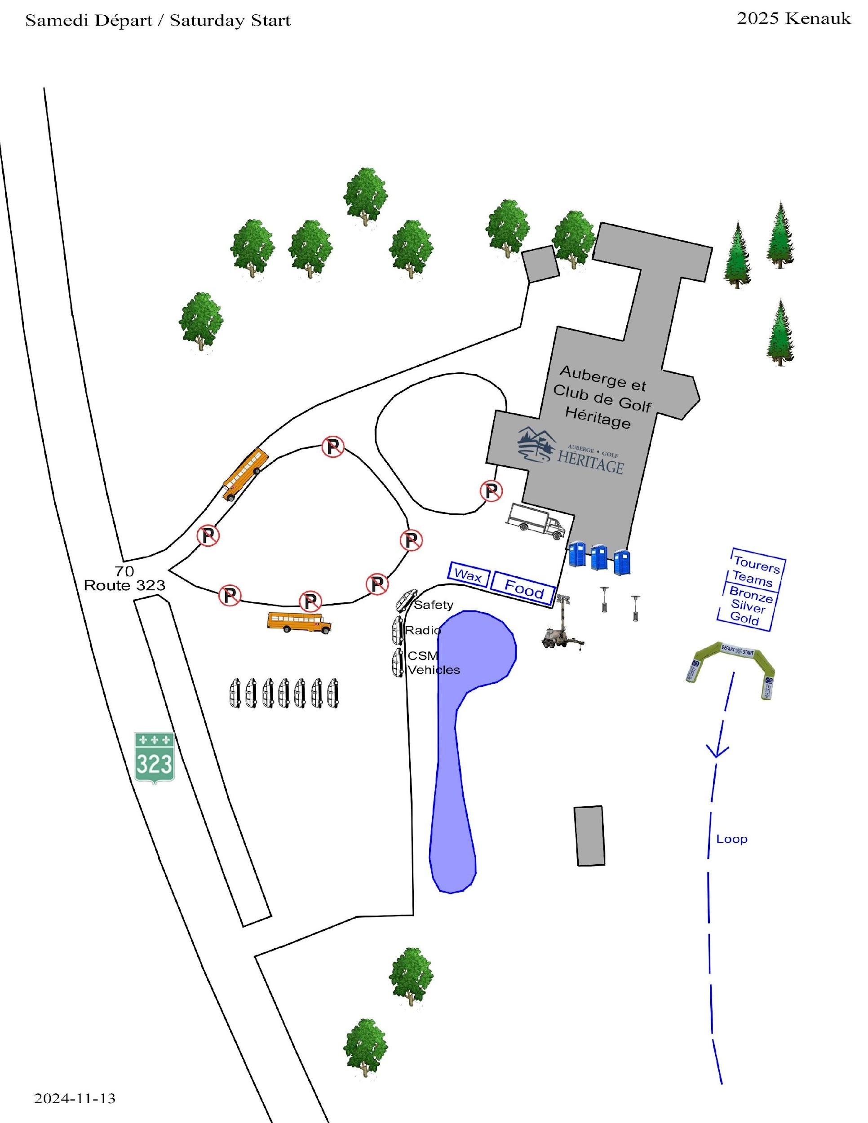

Taunton Checkpoint

Location:
- End of Chemin Taunton

45°47'39.6"N 74°50'41.0"W

Landowner
- Kenauk Nature

Communications:
- Commercial radio – operations and safety channels
- Good cell phone coverage without the need for a booster

Specific Tasks for Checkpoint Leader
- Buses are to remain at the bottom of the hill. Skiers will have to walk up the road to the checkpoint.
- The cube van, radio and safety vehicles should park on the old road where space is very limited. Other CP vehicles can park on the new road. Non-essential vehicles should park at the bottom of the hill.
- The trail entering and leaving the checkpoint on Saturday is bi-directional. Please ensure there are cones or dividers to safely separate skiers travelling in either direction so they don’t cross the wrong loop.
- This location is slightly different from the location in 2024, please make any necessary changes to your setup as you see fit to accommodate the new location.

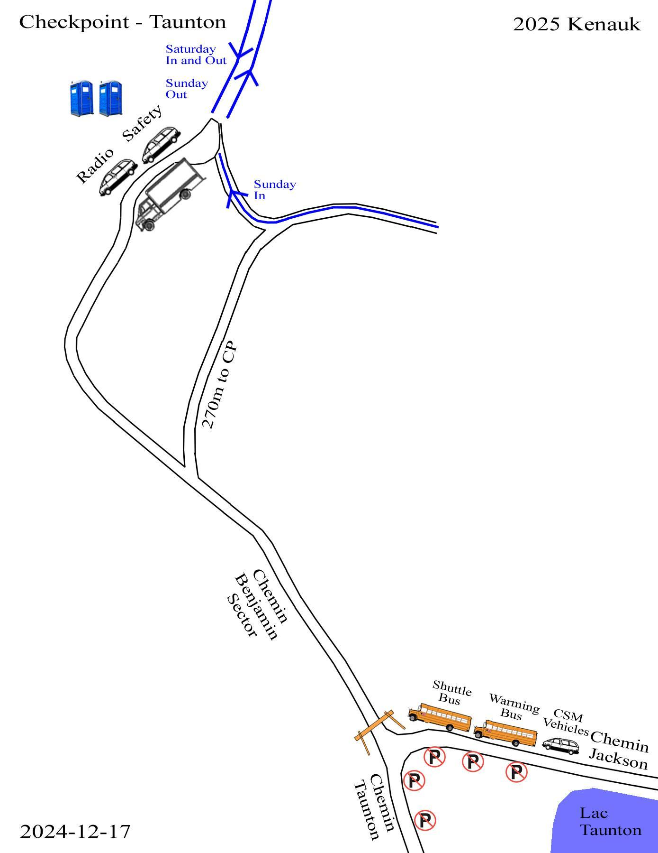

Esdale Checkpoint

Location:
- 402-554 Chem. du Lac à la Croix, Namur, QC J0V 1N0
- 45.869156683173486, -74.84303651735806

Landowner

Communications:
- Commercial radio – operations and safety channels
- Moderate cell phone coverage, but a booster helps.

Specific Tasks for Checkpoint Leader
- Ensure that the turning circle for buses is adequately plowed and level for buses to move without getting stuck.
- Keep skiers well separated from turning buses and trucks
- Allow for space for the chili team.
- The Half-Marathon will be departing from your checkpoint at 10:45; accordingly, several buses will be arriving just before that time. Please assist the driver by clearing enough space to allow for efficient unloading and turnaround.
- Do not allow half-marathoners to depart the checkpoint before 10:45, unless directly instructed by Admin-2.
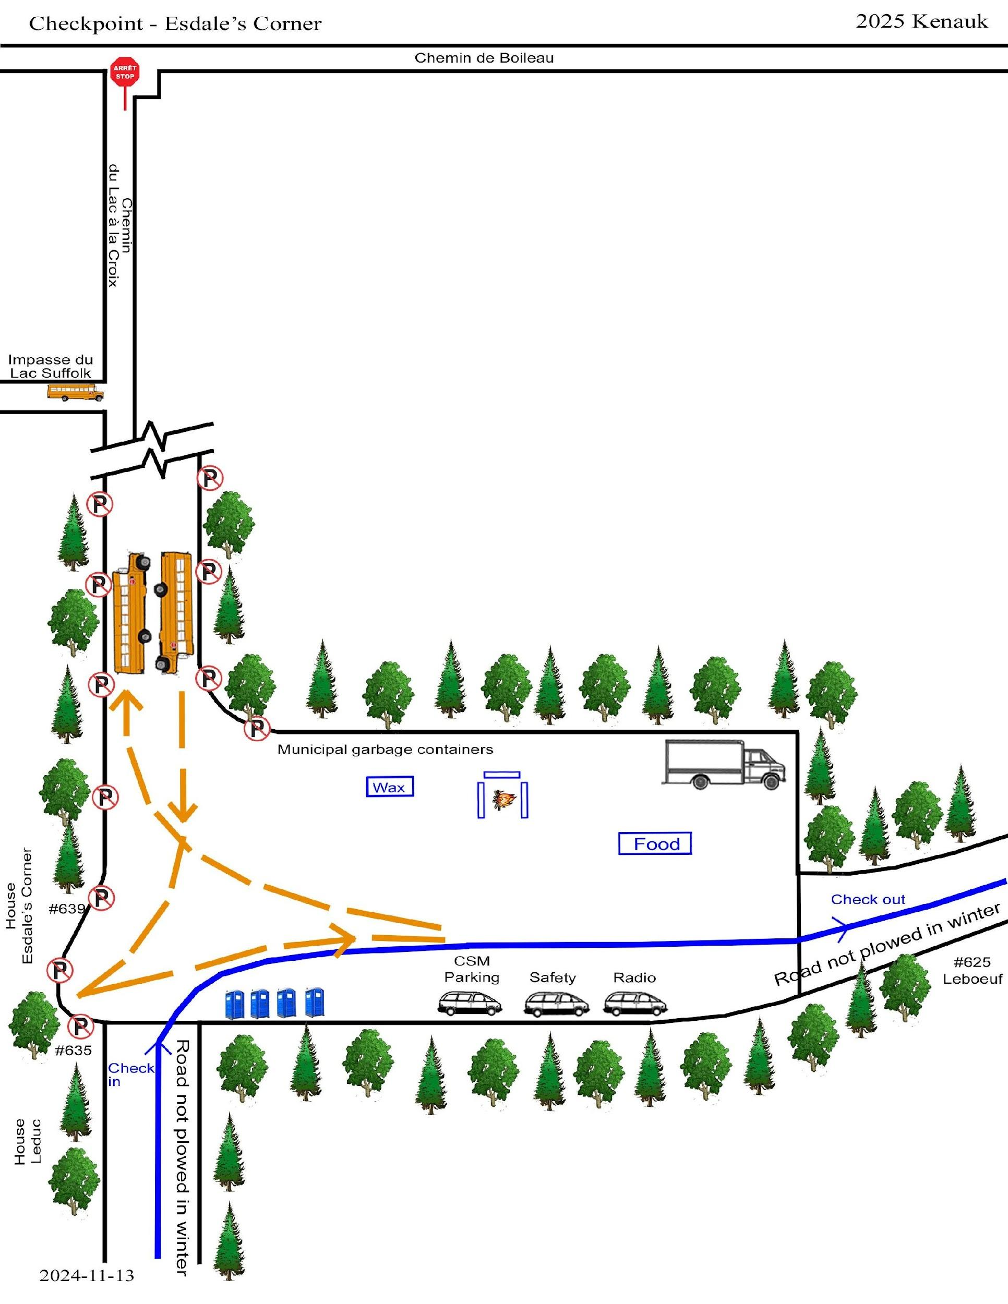

Sand Pit Checkpoint

Location:
- Chemin Taunton, Kenauk Reserve, Montebello
- N45° 45’ 48.5”, W74° 50’ 17.5”

Landowner
- Kenauk Nature, CSM weekend contact is Simon Trudeau, (819) 743-3487

Communications:
- Commercial radio – operations and safety channels
- There is no cell phone coverage, even with a booster
- We plan to have a Starlink connection for use by the chip team and CP leader only.

Specific Tasks for CP leader
- No private vehicles are permitted in the Kenauk Reserve.
- Volunteers will be stationed at the intersection of Côté Angèle and Chemin Kenauk to stop unauthorized vehicles.
- The gate at the entrance of the Chemin Kenauk will be left open all day.
- Part of Chemin Taunton between Lac Poisson Blanc and the checkpoint is narrow and does not allow two-way traffic. Buses will be instructed to communicate with each other using their own radio system to ensure that two buses don’t meet on the road.
- This location is slightly different from the location in 2024, please make any necessary changes to your setup as you see fit to accommodate the new location.
- The Half-Marathon will be departing from your checkpoint on Sunday at 10:30; accordingly, several buses will be arriving just before that time. Please assist the driver by clearing enough space to allow for efficient unloading and turnaround.
- Do not allow half-marathoners to depart the checkpoint before 10:30, unless instructed by Admin-2

Specific Tasks for Volunteers
- Weigh the backpacks of all silver Coureurs de Bois skiers as described in the General Instructions above.

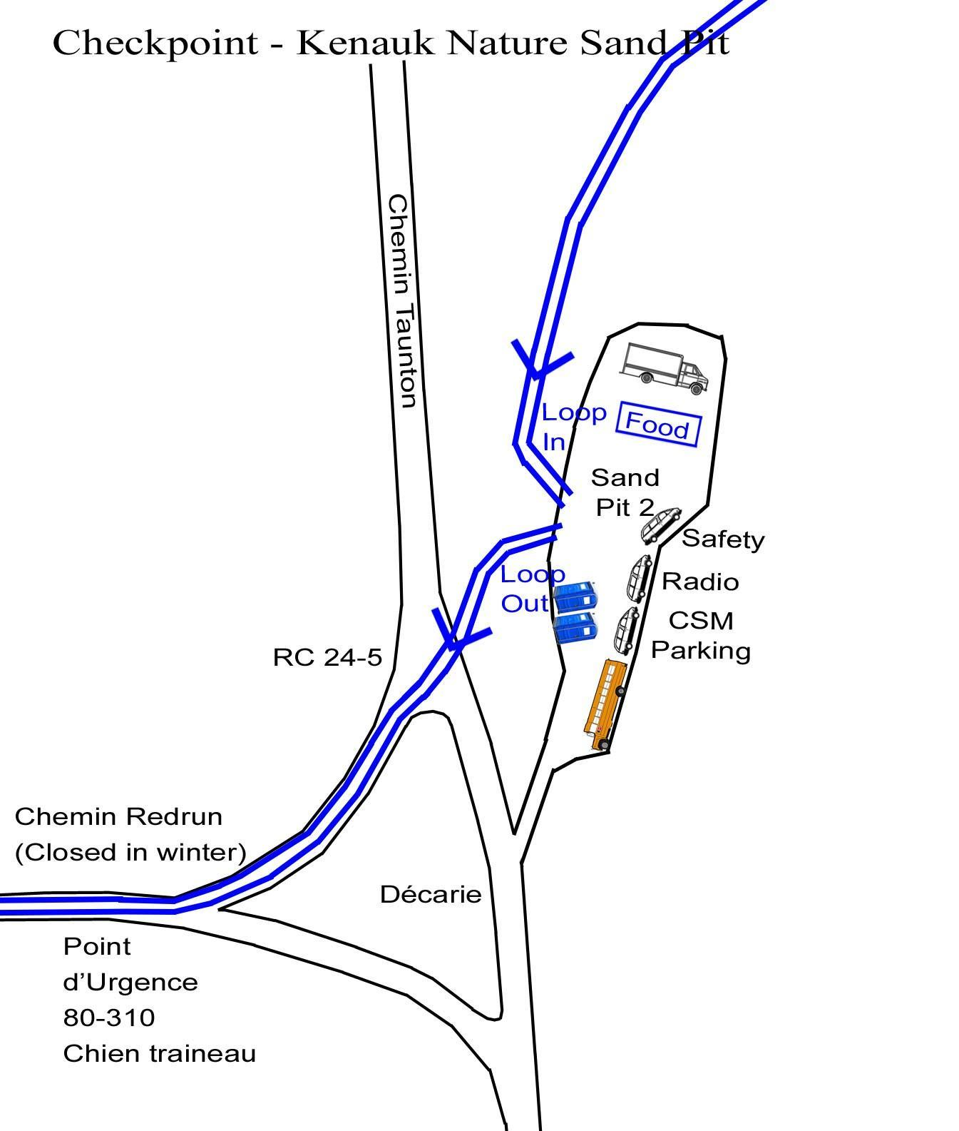

Checkpoint # 5 – Kenauk Reserve – Sporting Clay Field

Location:
- Chemin Kenauk, Montebello
- N45° 42’ 49.3”, W74° 51’ 26.4”

Landowner
- Kenauk Nature, CSM weekend contact is Simon Trudeau, (819) 743-3487

Communications:
- Commercial radio – operations and safety channels
- Cell phone coverage with Rogers is available, but weak, with a booster.
- No Bell coverage, even with a booster
- We plan to have a Starlink connection for use by the chip team and CP leader only.

Specific Tasks for Checkpoint Leader
- No private vehicles are permitted in the Kenauk Reserve.
- The lower gate at the entrance of the Chemin Kenauk will be closed all day to prevent non-authorized vehicles from entering. A volunteer at the gate will let vehicles enter who have a CSM permit.
- The driveway from Chemin Kenauk to the checkpoint is narrow and only allows one-way traffic. The Montebello fire department will also be stationed at each end with walkie-talkies to prevent two vehicles from being on the driveway at the same time. They are under the responsibility of the checkpoint leader.
- There is limited room at the checkpoint for vehicles. The only authorized vehicles on site should be shuttle buses, your cube van and checkpoint vehicles, a safety van, radio operator, a vehicle from the waxing team, Chip team, Admin-2, Logistics-1 and OPS/E&P. No other vehicles should be permitted to enter the driveway. Others must park on Chemin Kenauk and walk in.
- Ensure that you have somebody monitoring the driveway as soon as you arrive at the checkpoint.
- Make sure that the circular road around the checkpoint is never blocked.
- Install tape along the sides of the arriving and departing trails so that skiers cannot cross between the two trails.
- Install tape around the shooting stand to keep skiers off it.
- The small building is available for your use. Volunteers can use it to get warm. There is a gas stove in the cabin that needs to be lit at the start of the day. The pilot light isn't always on. The stove should be turned off at the end of the day.
- There is a room in the cabin with a sink and a washroom. The water is not turned on in winter so it is important that no skiers go in there. Block off the door to prevent skiers from entering it. Consider using the room for storage of bananas and honey so they don’t freeze.
- A garbage can should be placed inside the cabin for skiers
- The deck of the cabin may need to be shovelled and salted/sanded.

Specific Tasks for Volunteers
- Ensure that skiers keep off the circular road (keep it free for traffic).
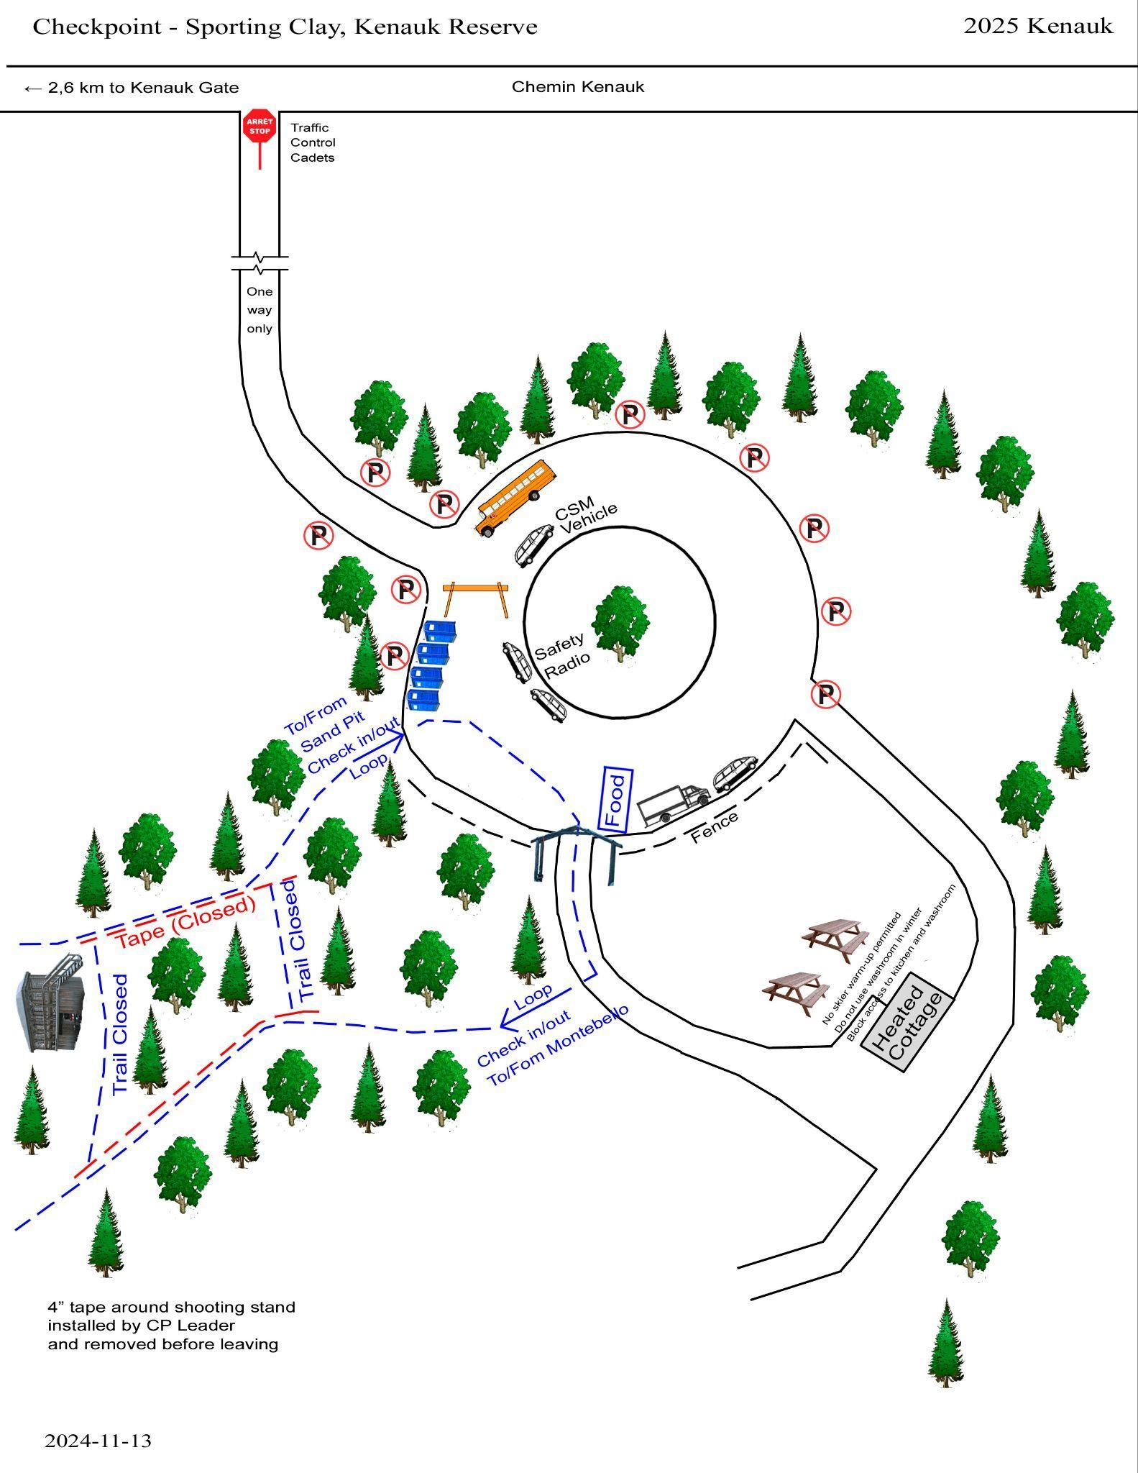

Montebello Finish

Location:
- Fabrique Notre-Dame de Bonsecours, 545, Rue Notre Dame, Montebello
- N45° 39’ 06.6”, W74° 56’ 24.4”

Landowner
- Municipality of Montebello

Communications:
- Commercial radio – operations and safety channels
- Strong cell phone coverage

Specific Tasks for Checkpoint Leader
- Place barricades on Rue Bonsecour to prevent all traffic between Rue Napoléon and Rue Henri Bourassa
- Review the set-up of the finish line arch, outdoor music and a/v equipment to announce the arrival of each skier. Obtain a wifi password or USB cellular stick for the announcing laptop from the Event Director.
- Review set-up of indoor vendor displays.

Specific Tasks for Volunteers
- Stop every skier as they cross the finish line. If they are not skiing on Sunday, ask them for their chip. Put the chips in the orange buckets. Skiers who plan to continue on Sunday keep their chip.
- All chips must be collected on Sunday
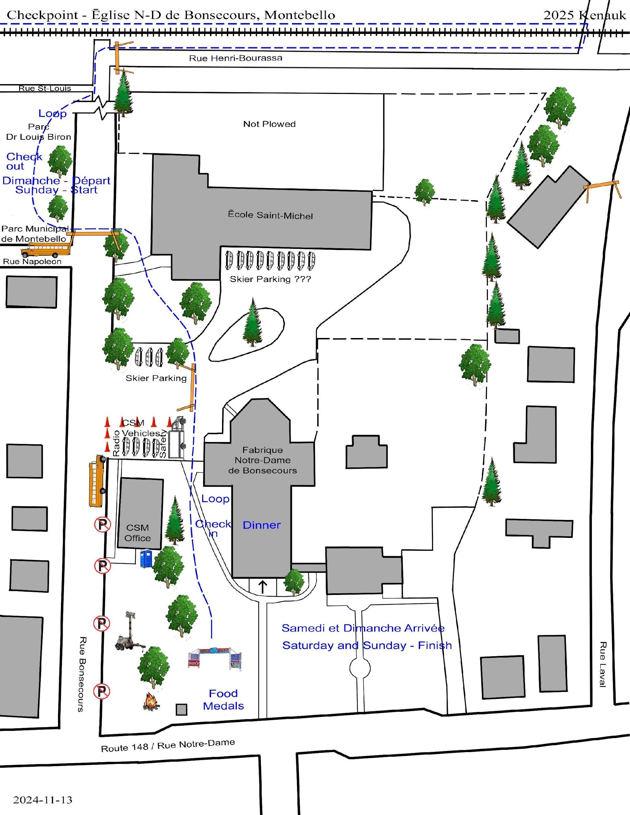

Gold Camp

Location:

574 Rue Henri Bourassa, Montebello QC
- 45.66283951227047, -74.93937600016936

Landowner
- Municipality of Montebello (the camp itself)
- Charles Huneault (the road from the sewage treatment plant to the camp) 819-665-6691

Communications:
- Commercial radio – Operations radio only on Saturday.
- Strong cell phone coverage

Specific Tasks for Checkpoint Leader
- Install barricades to prevent visitors from driving too far into the site.
- On Sunday morning, the Gold Coureurs de Bois should leave at 5:40. It is important that this time be respected, because CP # 7 might not be ready to receive skiers if they leave earlier. Skiers leave directly from Gold Camp and do not use the Sunday morning start for tourers.
- No skiers should leave the camp after 6:00 or after the sweep. Place cones or tape across the trail at check-out to prevent other skiers from starting here.
- Make a list of any Gold skier who does not ski out in the morning and provide it to Admin-2
- After the skiers have left on Sunday morning, burn all hay
- There should always be an adult with the youths when they are working on the site, i.e. cutting the wood or carrying hay.

Specific Tasks for Volunteers
- Provide firewood, hot water and hay to skiers at their campsites.
- Light fires for skiers using the propane flame thrower
- Mark the camping sign on the bibs of all Gold Coureurs de Bois skiers when they check IN.

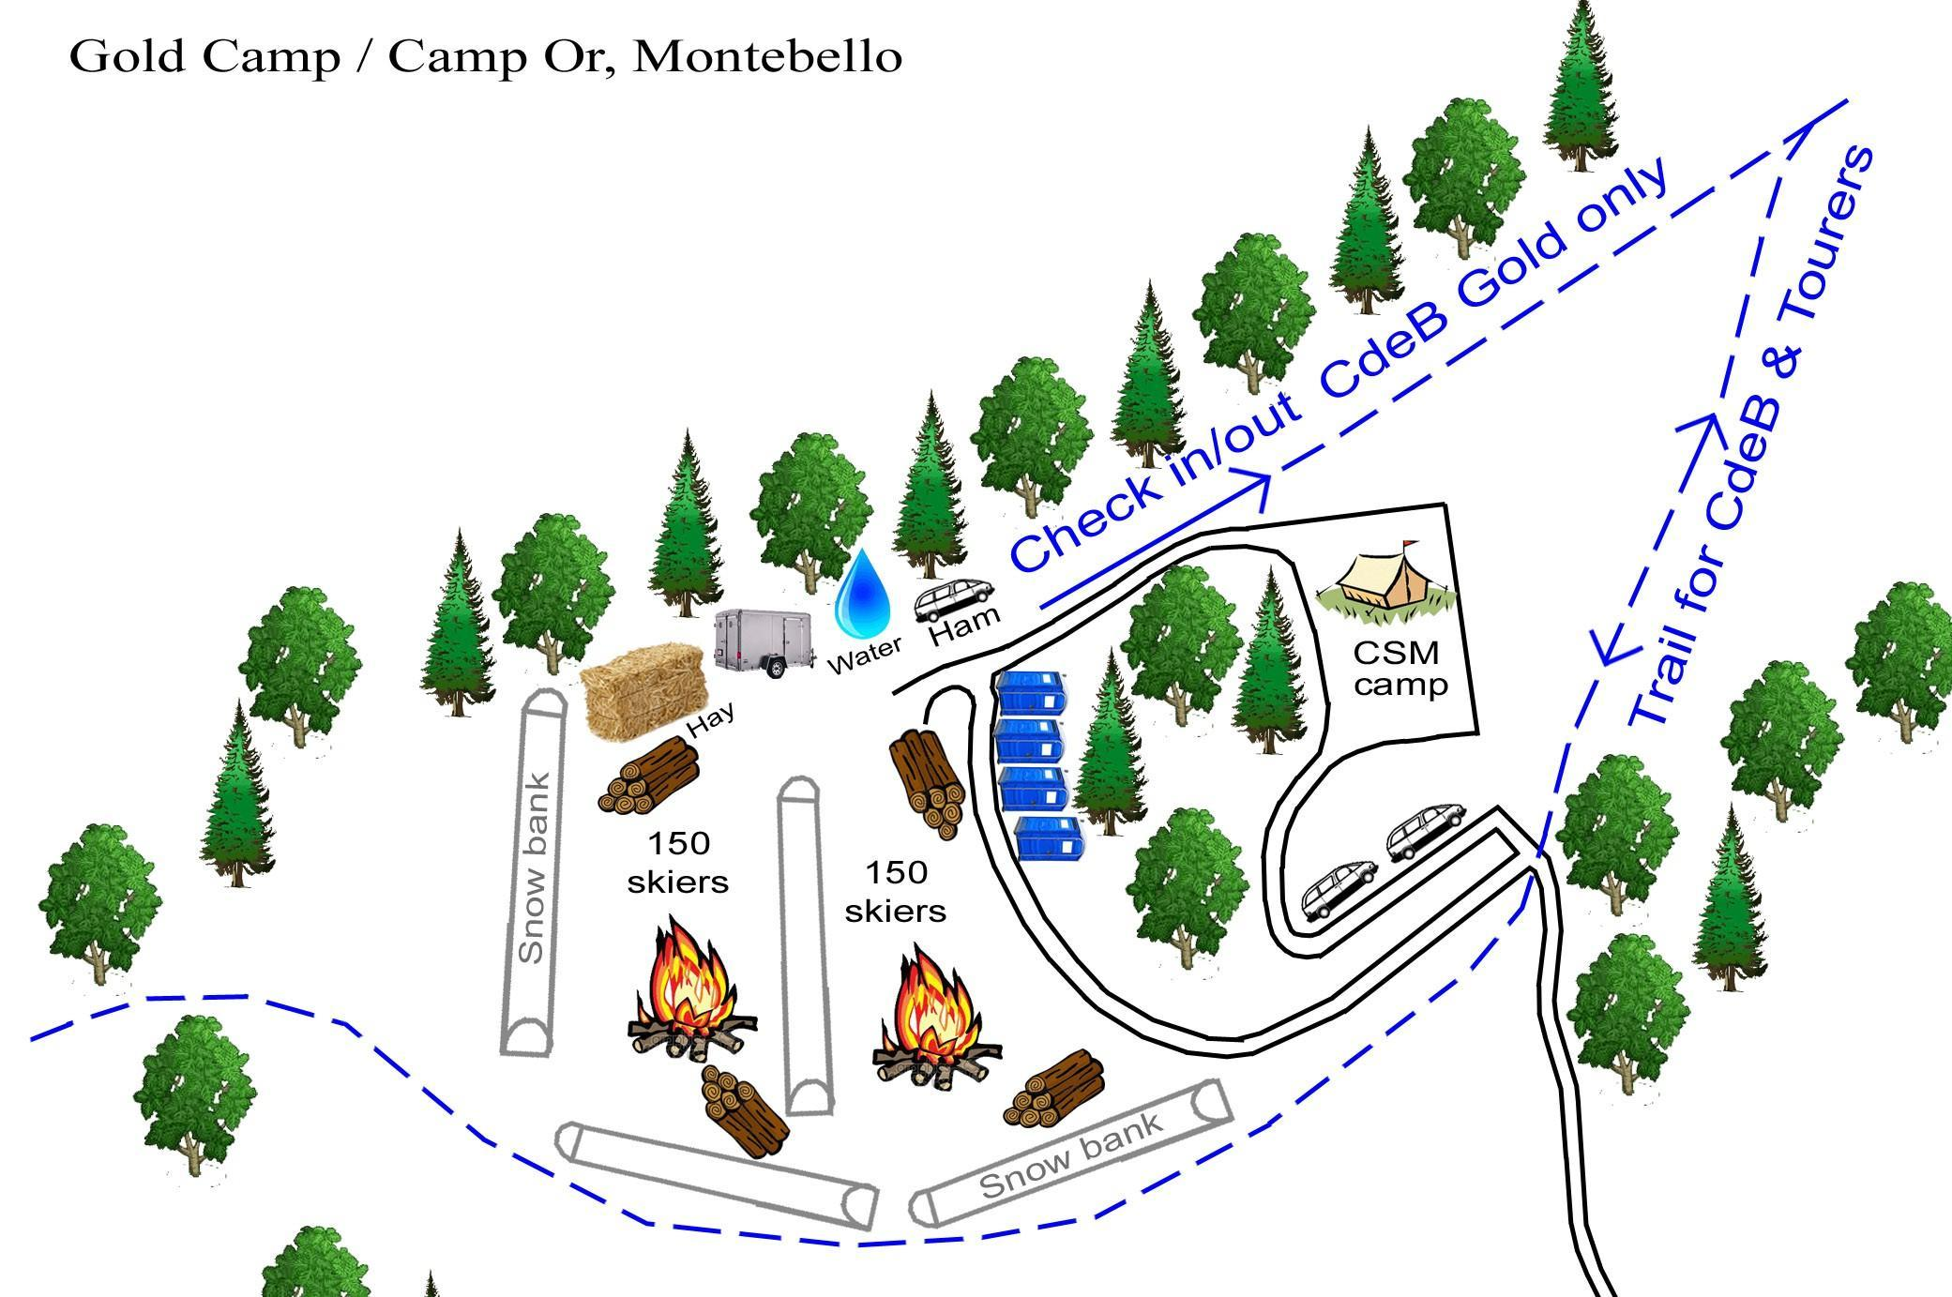

Sunday Start - Montebello

Location:
- Parc Municipale de Montebello, 275 Rue Bonsecours, Montebello, QC J0V 1L0
- 45.652513461557255, -74.9404448351958

Landowner
- Municipality of Montebello

Communications:
- Commercial radio – operations and safety channels
- Strong cell phone coverage

Specific Tasks for Checkpoint Leader
- Place barricades on Rue Bonsecour to prevent all traffic between Rue Napoléon and Rue Henri Bourassa
- Some skiers may be picking up their envelope with bib, chip and souvenir at the start. See instructions elsewhere in this document.

Specific Tasks for Volunteers
- Provide skiers with directions to washrooms, heated areas, and starting area.

Overview Map – Driving Directions

